Programme Name & Branch : B. Tech. (BCB, BCE, BCI, BCT, BDS & BKT)
Course Code and Course Name : BSCE306L / Artificial Intelligence
Faculty Name(s) : Prof. Priyadharsini M, Prof. Monash P, Prof. Jaisankar N, Prof. Jyotismita Chaki, Prof. Anindita Kundu, Prof. Geraldine Bessie Amali D, Prof. Saravanaguru RA.K, Prof. Mohana CM, Prof. Priyanka N, Prof. Rajakumar K, Prof. Lijo V.P, Prof. Shashank Mouli Satapathy, Prof. Gladys Gnana Kiruba B, Prof. Arpan Garai, Prof. Anand Bihari, Prof. Viswanathan P, Prof. Sivanesan S, Prof. Karthik K,Prof. Sudhakara Pandian R
Class Number(s) : VL2024250101495, 5795, 1424, 1468, 1472, 1453, 1428, 1484, 1487, 1433, 1480, 1458, 1478, 1503, 1482, 1437, 1476, 1492, 3566
Date of Examination : 17-Oct-2024
Exam Duration : 90 minutes Maximum Marks: 50
General instruction(s):
- Answer All Questions
- M - Max mark; CO – Course Outcome; BL – Blooms Taxonomy Level (1 – Remember, 2 – Understand, 3 – Apply, 4 – Analyse, 5 – Evaluate, 6 – Create)
- Course Outcomes
1. Evaluate Artificial Intelligence (AI) methods and describe their foundations.
2. Apply basic principles of AI in solutions that require problem-solving, inference, perception, knowledge representation and learning.
3. Demonstrate knowledge of reasoning, uncertainty, and knowledge representation for solving real-world problems
4. Analyse and illustrate how search algorithms play a vital role in problem-solving
Q. No | Question | M | CO | BL
1. | Consider a complete binary tree with the leaf nodes 5, 4, 3, 2, 8, 9, 10, 11, 3, 12, 2, 13, 15, 10, 14, 17 (left to right). Consider that tree as the game tree. By Applying mini-max search, show the backed-up values in the tree. Assume min takes the first call. If the nodes are expanded from left to right, analyze the efficiency if alpha-beta pruning is applied?  Ans:  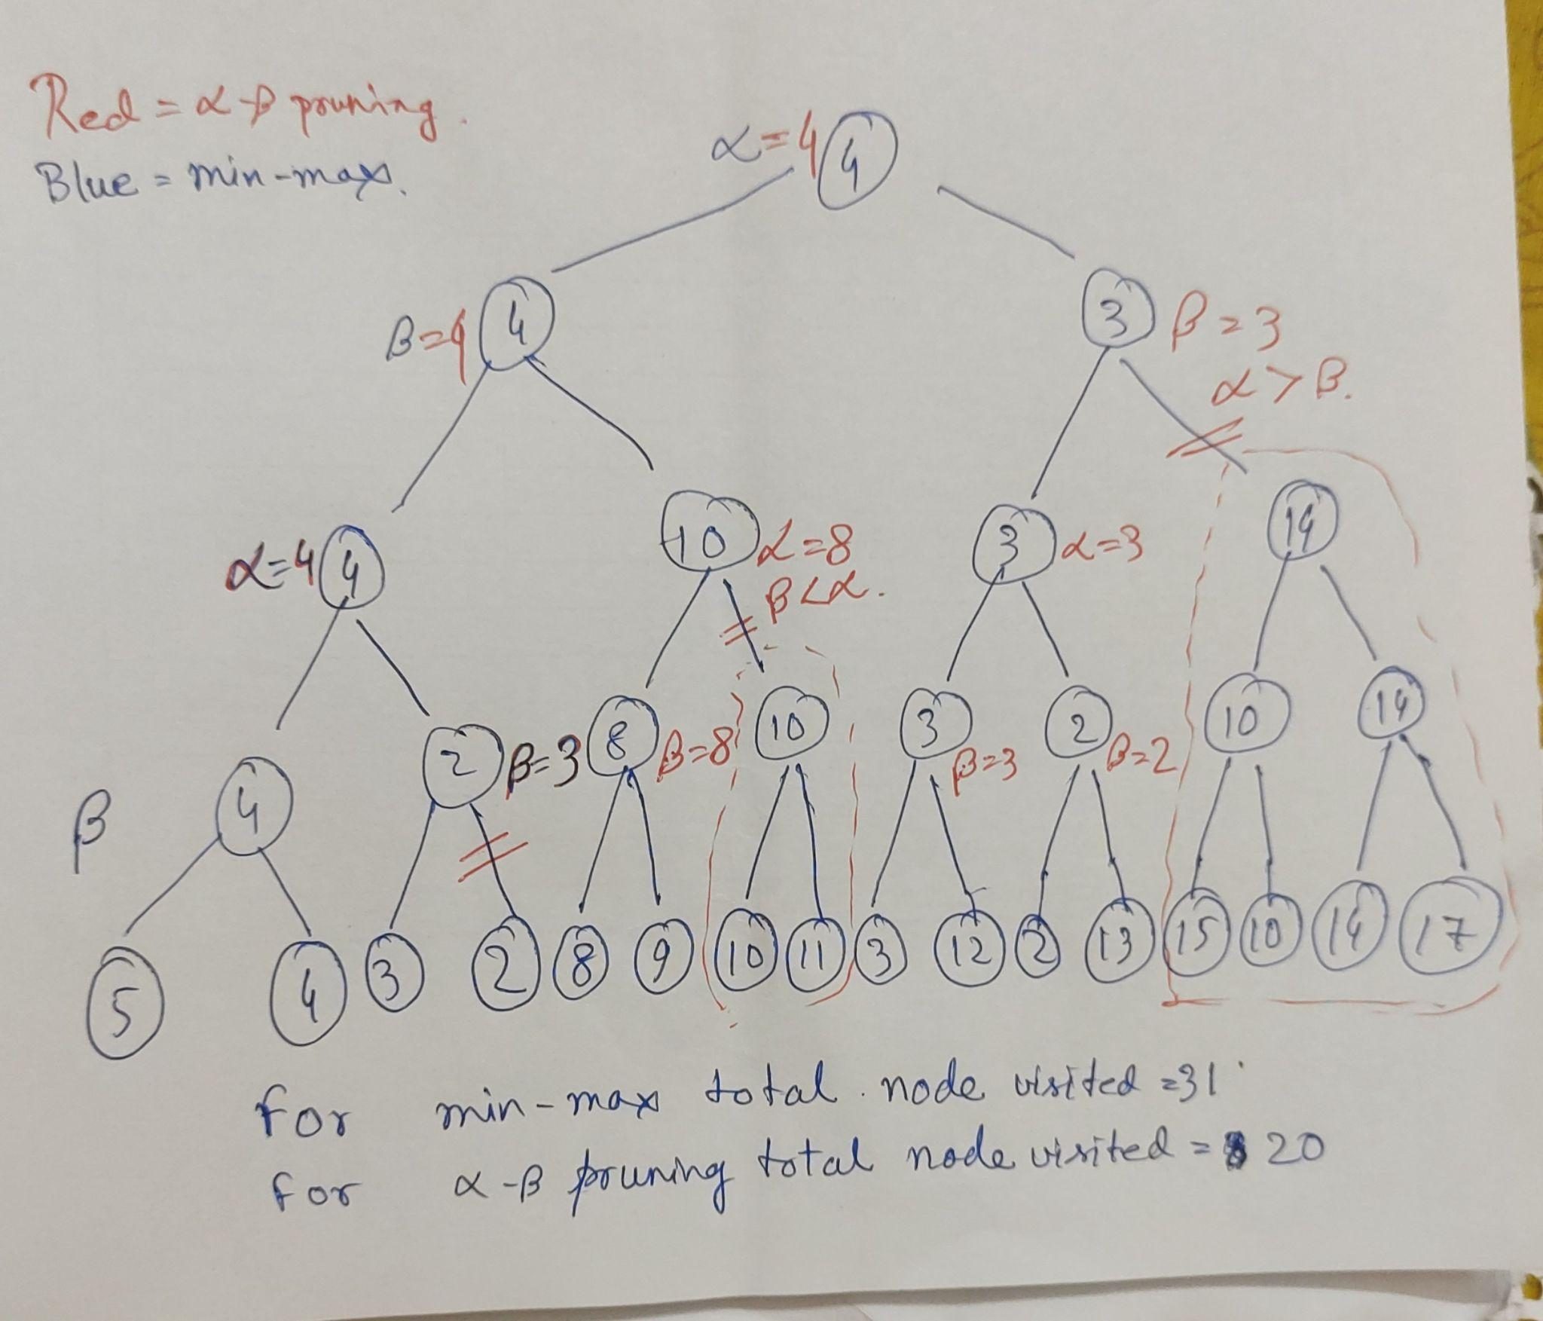 | 10 | 4 | 3
2. | Consider the following story of the "Successful candidate":  "Anyone good at coding or having an innovative mind or having recommendations will get a job. Anyone who practices coding or works in a research project becomes a good coder and innovative. Rahul is too lazy to practice code or work in a research project. However, his uncle will give him a letter of recommendation.” Prove using resolution that ”Rahul will get a job".  Ans:  1. Anyone good at coding or having an innovative mind or having recommendations will get a job.  ∀ x (Good_Coder(x) ∨ Innovative(x) ∨ haveRecommendation(x) → getJob(x))  2. Anyone who practices coding or works in a research project becomes a good coder and innovative.  ∀ x (Practices_Coding(x) ∨ Research_Project(x) → Good_Coder(x) ∧ Innovative(x))  3. Rahul's uncle will give him a letter of recommendation.  haveRecommendation(Rahul)  4. Rahul is too lazy to practice code or work in a research project.  ∼Practices_Coding(Rahul) ∧ ∼Research_Project(rahul)  —---------- 5 marks—----------  Put x = Rahul and start with the assumption Rahul will not get a job i.e. ~getJob(Rahul) … (5)  Start resolution from (5) and (1) to get (6)  Next, from 2 and 4, we get (~Good_Coder(Rahul) ∧ ~Innovative(Rahul)) … (7)  From (7) and (6) we get (8)  From (8) and (3) gets NULL.  —-----------5 marks—----------- | 10 | 2 | 4
3. | A. Convert the following English Statements into First Order Logic (FOL) (5)  i. Any house in Bhopal costs less than any apartment in Pune.  ii. Any 3 star washing machine costs less but consumes more power than a 5 star washing machine.  iii. There is exactly one person whose JEE rank is 14.  iv. There is a Villa in Mumbai which costs more than any other villa.  v. A person who loves his mother is loved by everyone.  B. Convert above First Order Logic (FOL) statements to Conjunctive Normal Form (CNF). (5)  Ans:  i. ∀x ∀y (House(x) ∧ LocatedIn(x, Bhopal) ∧ Apartment(y) ∧ LocatedIn(y, Pune) → Costs(x) < Costs(y))  ii. ∀x ∀y (WashingMachine(x) ∧ StarRating(x, 3) ∧ WashingMachine(y) ∧ StarRating(y, 5))  → (CostLT(x,y) ∧ PowerConsumptionGT(x,y))  iii. Part 1: There is at least one person whose rank is 14. ∃x (J(x, 14))  Part 2: At most one person has JEE rank 14.  (∀y ∀z ((J(y, 14) ∧ J(z, 14)) → (y = z))  Final Ans: (∃x (J(x, 14))) ∧ (∀y ∀z ((J(y, 14) ∧ J(z, 14)) → (y = z)))  iv. Part 1: ∃x (V(x) ∧ M(x))  "There exists a villa in Mumbai."  Part 2: ∀y ((V(y) ∧ M(y)) → (C(x) ≥ C(y)))  "For all villas in Mumbai, the cost of x is greater than or equal to the cost of y."  Final Ans:  (∃x (V(x) ∧ M(x))) ∧ (∀y ((V(y) ∧ M(y)) → (C(x) ≥ C(y))))  v. ∀x (Person(x)∧Loves(x, Mother)) → ∀y Loves(y, x)  B.  i. ∀x ∀y (∼House(x) ∨ ∼LocatedIn(x, Bhopal) ∨ ∼Apartment(y) ∨ ∼LocatedIn(y, Pune) ∨ Costs(x) < Costs(y))  ii. ∀x ∀y (∼WashingMachine(x) ∨ ∼StarRating(x, 3) ∨ ∼WashingMachine(y) ∨ ∼StarRating(y, 5) ∨ (CostLT(x,y) ∧ PowerConsumptionGT(x,y)))  iii. (J(f(y,z), 14)) ∧ (∀y (∼J(y, 14) ∨ ∼J(z, 14) ∨ y = z)) here, f(y,z) is for ∃.  iv.  (V(c))∧(M(c))∧∀y((¬V(y)∨¬M(y))∨(C(c)≥C(y)))  v. ∀x∀y((¬Person(x)∨¬Loves(x,Mother))∨Loves(y,x)) | 10 | 2 | 4
4. | A. There are three students, Anjali, Braian, and Chenna. One of them is a topper. When asked, they said the following.  Anjali: “I am not the topper.”  Braian: “I am not the topper.”  Chenna: “Braian is the topper.”  If only one person is telling the truth; Who is the topper? Formalize the puzzle in Propositional Logic and find the solution using a truth table. (3+2)  Ans:  A- Anjali is toper  B- Braian is topper  C- Chenna is topper  P- Anjali is telling the truth  Q- Braian is telling the truth  R- Chenna is telling the truth (3)  P Q R A B C  F T F T F F  T F T F T F  T T F F F T  According to question, there are only one person telling the truth. So, Anjali is topper. (2)  B. Explain how Modus Ponen and Modus Tollens can be used to infer logic with a real world example. (5)  Ans:  The Modus Ponens rule is one of the most important rules of inference, and it states that if P and P → Q is true, then we can infer that Q will be true. (1.5 marks)  Statement-1: "If I am sleepy then I go to bed" ==> P→ Q  Statement-2: "I am sleepy" ==> P  Conclusion: "I go to bed." ==> Q.  Hence, we can say that, if P→ Q is true and P is true then Q will be true. (1 marks)  The Modus Tollens rule state that if P→ Q is true and ¬ Q is true, then ¬ P will also true. (1.5 marks)  Statement-1: "If I am sleepy then I go to bed" ==> P→ Q  Statement-2: "I do not go to the bed."==> ~Q  Statement-3: Which infers that "I am not sleepy" => ~P (1 marks) | 10 | 2 | 5
5. | A. Explain Bayes' rule with a suitable example. (3)  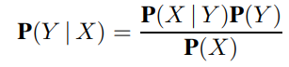  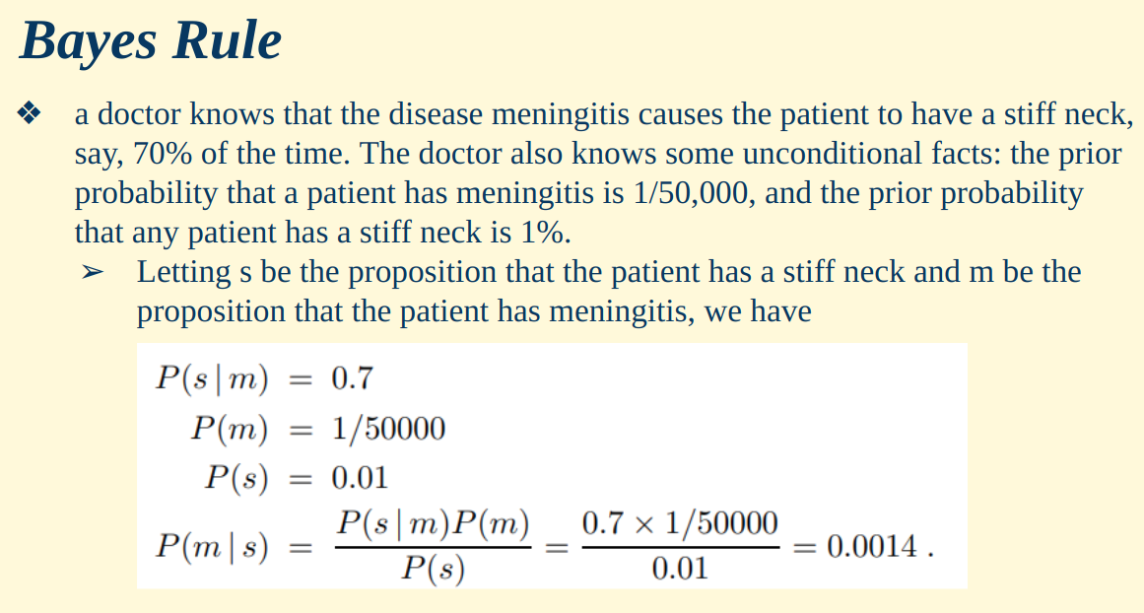  B. In a reputed engineering college, there are 1000 students. Among them, 700 students got placement offers. Overall, it is seen that 82% of the candidates are strong in ‘C language’ among the selected candidates. In the class, 660 students are strong in ‘C language’. Sweta is strong in ‘C language’. How likely is she to get the placement offer? Map the scenario into a set of propositions and apply Bayes' rule to solve the problem. (7)  Ans:  P = A candidate got placed.  C = A candidate is strong in C (2 marks)  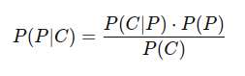  P(P) = 0.7  P(C) = 0.66  P(C|P) = 0.82  P(P|C) = 0.82 * 0.7 / 0.66 = 0.8696 | 10 | 3 | 5
**********************

